MAJOR PROJECT REPORT
On
Food Nutrition Estimator From Image and Text using AI
Submitted to
Amity University, Uttar Pradesh

In partial fulfilment of the requirements for the award of the degree of
Bachelor of Technology in
Computer Science and Engineering
Under the guidance of:
Dr Roshan Lal
By:
Kushagra Pankaj(A023166922048)
B. TECH CSE IOT AND CYBERSECURITY INC. BCT
2022-2026
DEPARTMENT OF COMPUTER SCIENCE AND ENGINEERING
AMITY SCHOOL OF ENGINEERING AND TECHNOLOGY
AMITY UNIVERSITY UTTAR PRADESH
NOIDA (U.P.)

DECLARATION
I, Kushagra Pankaj student of B.Tech CSE (IoT and Cybersecurity including BCT) hereby declare that the Major Project Report titled "LiveFit — AI-Powered Nutrition & Meal Management Mobile Application", submitted to the Department of Computer Science and Engineering, Amity School of Engineering and Technology, Amity University Uttar Pradesh, Noida, in partial fulfilment of the requirement for the award of the degree of Bachelor of Technology in Computer Science and Engineering, has not previously formed the basis for the award of any degree, diploma, or other similar title or recognition.

Place: NOIDA Kushagra Pankaj (A023166922048)

CERTIFICATE
On the basis of the declaration submitted by Kushagra Pankaj, student of B.TECH Computer Science and Engineering (Internet of Things and Cybersecurity including Blockchain Technology), I hereby certify that the Major Project titled "LiveFit — AI-Powered Nutrition & Meal Management Mobile Application" submitted to the Department of Computer Science and Engineering, Amity School of Engineering and Technology, Amity University, Noida, in partial fulfilment of the requirement for the award of the degree of Bachelor of Technology in Computer Science and Engineering, is an original contribution with existing knowledge and faithful record of work carried out by them under my guidance and supervision.
To the best of my knowledge, this work has not been submitted in any part or full for any degree or diploma to this university or elsewhere.

Place: NOIDA

Dr. Roshan Lal
Associate Professor Grade-III
Department of Computer Science and Technology
Amity School of Engineering and Technology
Amity University Uttar Pradesh, Noida, UP

ACKNOWLEDGEMENT
I take this opportunity to express our profound sense of gratitude and respect to all those who helped us throughout this project. I am grateful to our faculty guide Dr. Roshan Lal, Associate Professor-III, Amity School of Engineering and Technology (ASET), for guiding me and helping me with every detail in completing this project. I extend thanks to him for imparting valuable guidance in all aspects. I am also grateful to Prof. (Dr.) Sanjeev Thakur (HoD), Department of Computer Science and Engineering, for regular encouragement and motivation.
I would also like to extend my gratitude to our families and friends who helped and encouraged me to complete this project with utmost sincerity. Above all, I pay our reverence to the Almighty.

Place: Noida Kushagra Pankaj (A023166922048)

Abstract
LiveFit is an all-inclusive, full-stack, nutrition and meal management solution based on AI-enhanced technology that aims at closing the gap between food awareness and individual dietary recommendations. In a time where the non-communicable diseases that are associated with a bad diet are growing drastically particularly in urban India, users are increasingly demanding smart, convenient, and personalised applications to control their eating habits. LiveFit also fills this requirement by integrating a cross platform mobile application (written in React Native and Expo), a modern web app, and a powerful cloud-hosted platform into a unified ecosystem. The platform itself simplifies and is based on an intelligent food identification engine that allows one to enter the name of the food or take a photo and then it identifies the food. On submission of an image a hybrid machine-learning pipeline is called, in which a locally-hosted Python FastAPI microservice serves the Hugging Face transformer model 'rajistics/finetuned-indian-food' which is specially trained to recognise Indian dishes. When the model is below 60 per cent in confidence, the system transparently reverts to the Roboflow computer vision API which is able to identify the unusual and ambiguous food photographs strongly. The name of the identified food is then matched against a prioritised, dual, database, nutritional look up strategy. In the case of Indian food, the system interrogates an Indian Food Composition Tables (IFCT) dataset of exact, partial, and reverse fuzzy matched database giving very precise macronutrient data of thousands of subcontinental foods. On the rest of the food products, the system makes a query to the USDA FoodData Central API which is an international authoritative nutritional database.
In addition to food logging, LiveFit also has Google Gemini 2.5 Flash, which is a conversational nutrition coach based on AI. This AI assistant receives the real-time data regarding the nutritional intake of the user and provides a personalised and acting dietary advice to the natural language questions, recognises macro deficiencies or excesses and provides the appropriate food options. The platform also includes a reward ecosystem that is gamified to incentivize regular food logging whereby the user earns LiveFit Coins, which can be then used to purchase digital items such as discount codes based on percentage, free meals, Pro subscriptions, and nutrition reports in a dedicated store. The discount codes are directly coded with Razorpay payment gateway and gives the user the option to use authenticated coupon codes at checkout where the price is updated real-time. There is a level of subscription (Free and Pro) that opens special capabilities such as an unlimited AI coach interaction and better analytics. The meal ordering part will enable them to view a recommended list of health-optimised meals, add to a permanent cart, and reserve the purchase with the help of Razerpay, and PDF invoices will be automatically created at the time of order placement. All user information is safely stored within a cloud MongoDB Atlas database, its authentication is done with the help of bcrypt password hashing and the stateless session management on the application is enforced under the use of the JSON Web Tokens.

TABLE OF CONTENTS
Section | Page
Chapter 1: Introduction | 1
Chapter 2: Literature Review | 8
Chapter 3: Technologies & Tools | 11
Chapter 4: System Design & Architecture | 13
Chapter 5: Implementation | 15
Chapter 6: Security, Privacy and Scalability | 21
Chapter 7: Limitations | 23
Chapter 8: Results | 24
Chapter 9: Conclusion | 34
References | 35

List of Figures
Figure No. | Title | Page No.
Fig 3.1 | Backend Middleware Stack | 11
Fig 4.1 | Backend API Route Map — All 25+ REST Endpoints Grouped by Category | 13
Fig 5.1 | Reward Lifecycle Flow — Food Log to Coin Award to Discount Code Redemption | 16
Fig 5.2 | IFCT Fuzzy Matching Logic — Three-Level Resolution Strategy in ifct.js | 17
Fig 5.3 | MongoDB Atlas — User Collection showing bcrypt-hashed passwords | 18
Fig 5.4 | MongoDB Atlas — UserReward Collection showing discount codes and usage state | 18
Fig 5.5 | MongoDB Atlas — Subscription Collection with 30-day plan windows | 19
Fig 5.6 | MongoDB Atlas — Order Collection with confirmed orders and pricing | 19
Fig 5.7 | MongoDB Atlas — Meal Collection with nutritional and pricing data | 20
Fig 5.8 | MongoDB Atlas — Food Log Collection with per-meal nutrient entries | 20
Fig 5.9 | MongoDB Atlas — Cart Collection with item arrays | 21
Fig 6.1 | JWT Authentication Flow — Signup, Login, and authMiddleware Verification | 22
Fig. 8.1 | Bar chart comparing average and 95th-percentile latency across all API endpoints | 25
Fig. 8.2 | Error Rate (%) by Endpoint Category | 26
Fig. 8.3 | IFCT vs. USDA: Coverage, accuracy, and error comparison for Indian dishes | 28
Fig. 8.4 | Chatbot Performance | 29
Fig. 8.5 | Earning of Coins | 30
Fig. 8.6 | Performance Testing | 32

List of Tables
Table No. | Title | Page No.
Table 1.3.1 | Core Components of LiveFit | 3
Table 8.1 | API Performance Benchmark Results | 24
Table 8.2 | Error Rate | 26
Table 8.3 | Text Input Test Cases | 27
Table 8.4 | Image Classification Pipeline Test Cases | 28
Table 8.5 | IFCT vs. USDA Accuracy Comparison | 29
Table 8.6 | AI Coaching Quality Assessment | 30
Table 8.7 | Reward System | 31
Table 8.8 | Payment Flow | 31
Table 8.9 | Load Testing Results | 32

Chapter 1: Introduction

1.1 Background
Scientific knowledge of the connection between diet and health has never been as clear, but to apply nutritional knowledge in everyday life is one of the most challenging. perennial social health issues of the modern world. The World Health has indicated that it is. An estimated 2.8 million people are killed every year as a result of being. Obese or overweight, and there is an additional colossal load which is ascribed to micronutrient. nutritional deficiencies and diet related non-communicable illnesses such as diabetes, cardiovascular disease, and some cancers [27]. The dual burden in India particularly. obesity and metabolic syndrome with their rapid growth expose a singular. complicated dietary environment and requires culturally competent and technologically advanced solutions. Conventional food diary techniques such as paper food diaries, as well as generic calorie. tallying tables, and universal nutritional guidelines have been shown to be systematic. inadequate. They are cumbersome, inaccurate, culturally ill-illustrated to the extraordinary. diversity of Indian food, and is essentially out of touch with the live feedback. circles that have been provided by modern behavioural science to be fundamental in sustainable habit. formation. The rapid growth in using smartphones particularly among the rapidly increasing population in India. growing middle, offers a historic challenge to implementation of intelligent, individualised nutritional applications at the population level.
LiveFit was the idea created to bridge this gap [4][5]. Instead of it presenting a fixed. LiveFit is an active nutrition-based smart weighing system that fulfills the needs of calorie counting. wherever they are, users can capture a photo of a thali they cooked at home or find the location of the thali around them. contain macronutrients in a packaged food product, and is responsive to an immediate reaction. individualised, and contextualised nutritional advice. The site is created in a user-friendly way. better be an Indian-first ground-up to allow the IFCT nutritional database and a fine. used in tuned food recognition of Indians, but perfectly able to operate on global. the cuisines via the USDA integration.

1.2 Problem Statement
Although the work on health and fitness applications is gaining momentum in recent years, a substantial portion of the population, especially Indian people, remains to encounter significant obstacles on their way to the correct monitoring of nutritional intake. The obstacles have a multi-dimensional nature. To start with, there is the issue of coverage of Indian food. Even the nutrition applications currently in place are constructed on Western food databases, especially the USDA database, which hardly covers thousands of individual Indian dishes eaten daily all over the subcontinent. One trying to enter dal makhani, ‘aloo paratha', or 'rasam' will frequently find either no match, an incorrect match, or nutritional data that bears little relationship to the actual composition of the dish as typically prepared in India. Second, one is the manual food logging. It has been repeatedly shown by research that the cognitive and temporal burden of the very process of dietary tracking is the sole most predictive factor of dietary tracking adherence [4][6]. How many of them will abandon the use of tracking applications in days of installation after having to manually search and select the foods, manually estimate the portion sizes, and key-type in the quantities?
Third, there is the lack of smart and personalised feedback. The vast majority of nutrition apps are little more than a ledger book, holding what has been eaten, without applying actually useful advice on what a change would be best helping the health interests of the application user. In the absence of this intelligent feedback loop the motivational value of tracking data decays very quickly.
Fourth, there is the challenge of sustaining user engagement over time. Health behaviour change is inherently a long-term project, and applications that fail to maintain user engagement beyond the initial novelty phase cannot deliver meaningful health outcomes. Gamification, social features, and reward mechanisms have been shown in the literature to significantly improve long-term engagement, but few nutrition applications implement these mechanisms in a sophisticated or genuinely rewarding way.
LiveFit addresses all four of these problems through an integrated system architecture that prioritises Indian food recognition, minimises logging friction through AI-powered identification, provides real-time intelligent coaching through generative AI, and sustains engagement through a meaningful coin and reward ecosystem.

1.2.1 The Indian Nutrition Gap in Detail
India's nutritional diversity is staggering. With over 7,500 distinct dishes documented across 28 states and 8 union territories, each with unique ingredients, preparation methods, and regional variants, no single Western-designed database can adequately serve an Indian user. Consider the simple case of 'sambar': the Tamil Nadu version differs markedly in composition from the Karnataka or Kerala variant, and the homecooked version differs further still from restaurant preparations. Caloric estimates derived from generic databases may err by 30–50% for such dishes, systematically corrupting the dietary records of millions of users who rely on these applications for health management.
This issue is further exacerbated by the organization of typical Indian cuisine, which hardly fits into the discrete groupings to which database-based applications are more accustomed. An average North Indian thali has six to ten items at once, of which a large number are cooking specific combinations of items having no database representation. Similar problems are faced by South Indian tiffin, Bengali fish curries and Gujarati farsan. Such a structural dislocation between the Indian dietary pattern and the presuppositions used in the current digital tracking tools is the largest obstacle to the use of nutrition applications amongst the Indian marketplace.

1.2.2 The Engagement Deficit in Health Applications
In addition to the question of accuracy, there is a long-reported engagement crisis in the health application industry. The industry records have been consistent in revealing that more than 8 out of ten applications users of the health and fitness apps drop their application of choice within the first month of installation. The reasons are multifactorial, such as the friction of manual data entry, the lack of meaningful progress feedback, the lack of social accountability mechanisms, and the inability to give tangible rewards to engage in the sustained engagement. Successful applications, which continue to attract the interest of customers over time, always have these elements in common: sleek interface designs, smart personalisation, purposeful progressions, and concrete reward models. LiveFit is built with an initial aim of having all these four retention mechanisms.
The gap in economic aspects of this involvement is also notable. Users who lack the motivation to continue with nutrition applications are usually those who do not find the perceived cost of using the applications to offer more than the perceived value. It is especially acute during the first two to four weeks of the utilization before any significant health outcome could be observed. The only solution to this disparity is to create instant, tangible value every time you interact with someone an idea reinforced by the practice of rewarding LiveFit members with a coin whenever they log food, so that each tracking behaviour would create an instant, visible, and economically significant benefit.

1.3 Proposed Solution
Livefit suggests a complete hybrid solution that will combine computer vision, natural language AI, gamified reward and curated database of nutritional data into one user experience. The solution has been designed to work on two supplementary surfaces: a mobile app implemented in React Native and Expo to log meals on the go and coach and a web app implemented in vanilla HTML, CSS, and JavaScript to have more sophisticated experiences of browsing and management.
The technical centre of the system is the food identification line. Upon uploading a food photograph, this is sent to a Python FastService that is locally hosted and serves a finetuned vision transformer model directly trained on the categories of Indian food. It is supported by instant and low-latency reactions with zero per-ask API expenses on the most frequent query. By using a confidence threshold mechanism, the local model only accepts the high confidence prediction, otherwise the local model activates an automatic fallback to an external fallback Roboflow computer vision API that offers a strong safety net to weird foods or photographs of less-than-optimal quality.
The nutritional resolution layer puts into effect a prioritised dual-database strategy. The embedded IFCT data is first searched using the identified Indian food items and includes detailed macronutrient profiles of traditional Indian foods. The non-Indian (or Indian food not available in IFCT) foods are matched against the USDA Food data Central API. This is a stratified method that would maximise precision of the Indian cuisine, and generous coverage of international foods.

Table 1.3.1: Core Components of LiveFit
Feature | Implementation | User Benefit
Food ID by Image | HuggingFace + Roboflow hybrid  ML pipeline | Zero-friction photo-based logging
Food ID by Text | IFCT + USDA dual-database lookup with fuzzy matching | High accuracy for Indian & global foods
AI Coaching | Google Gemini 2.5 Flash with real-time nutrition context | Personalised dietary advice  24/7
Gamification | Coin earning + redemption reward store | Sustained long-term engagement
Meal Ordering | Curated health-focused menu +  Razorpay payment | Healthy food delivery integration
Subscriptions | Free / Pro tiers via Razorpay | Monetisation with premium features
Secure Auth | bcrypt + JWT + email reset | Enterprise-grade account security
  - Objectives
- The project intends to meet the following main objectives that seek to fill a certain gap in the existing sphere of nutrition technologies applications
- Build a complete functionality nutritional tracking system with mobile and web interfaces, so that any type of user can use the entire set of functionalities.
- Installed a potentially effective pipeline. A high-accuracy hybrid food recognition pipeline between local fine-tuned machine learning and cloudcomputer-vision fallback providing high reliability food recognition of local Indian cuisines and globally.
- Implement nutritional resolution system with a dual-database platform (using the IFCT dataset of Indian food and the USDA Fooddata central API of global food) to give precise data on macronutrients of thousands of food products.
- Implement a text-based AI nutrition coaching application based on Google Gemini 2.5 Flash, which can give the user customised nutrition information depending on the real-time data of his/her nutrition.
- Develop and deploy a gamified coin and reward ecosystem that offers rewards to long-term food logging and ordering healthy meals to increase user retention and loyalty to the platform.
- Combine fully functional payment system with options to purchase meals and upgrade subscription with Razorpay, and automatically create PDF receipts on all accepted orders.
- Make sure that the entire platform is secure with the use of the password hashing algorithm BCrypt, stateless authentication using JWT and the communication between the APIs being secure.

1.4.1 Technical Objectives
Technically, the project will aim to show that, with entirely open-source software and free-tier cloud service usage, it is possible to contemplate the construction of a production-quality AI-powered health platform and deploy it, which would mean that the approach to architecture can subsequently be replicated and used in the future by other researchers and commercial developers. The system in particular addresses the following technical goals: reaction to queries based on the images in less than 2 seconds, accuracy in nutritional lookup of over 90 percent in response to common Indian dishes, accuracy in AI coaching response at the level of rule-based dietary advice systems, and payment collection rate that is on par with the rest of the Razorpay platform.

1.4.2 Research Objectives
In the framework of the research perspective, the project will help to confirm various empirical hypotheses, which have far-reaching implications to the overall sphere of digital health. To begin with, the fact that fine-tuned domain-specific vision transformer is superior to general-purpose computer vision APIs in recognizing Indian food. Second, the relevance and accuracy of dietary advice is significantly improved by such real-time contextual grounding of responses of large language models, which is quantifiable. Third, the gamification functions based on physical economic incentives enhance food logging adherence in short-term much better than applications based on passive tracking. They are tested with the help of the functional prototype and assessed using structured test cases in Chapter 6.

1.4.3 Social and Health Objectives
On the biggest scope, LiveFit would help increase the nutritional-related health results of the urban Indian population by ensuring that proper and personalised dietary recommendations are available to any person who has a smartphone. The noncommunicable disease burden of India, such as the largest number of diabetic patients in the world, the fastest growing rates of cardiovascular disease, and the lack of micronutrients among the socioeconomic population, leads to the compulsive requirement of tools to provide nutrition interventions on a wide scale and at affordable prices. Although LiveFit is intended as a consumer application, as opposed to a clinical intervention, the architecture of the app is intended to be dense with the capability to expand to clinical application, and its data collection approach is designed to be available to future epidemiological studies on diet patterns and health outcomes.

1.5 Scope of the Project
LiveFit is planned and developed as a production ready Proof-of-Concept platform that will serve health-conscious and fitness passionate and nutrition-conscious customers, especially in urban India. The system is structured to be used by individual consumers instead of being used in a clinical or enterprise application environment, and it thus focuses on user experience, engagement models, and functionality instead of such facilities as clinical dietitian workflow, integration with medical records, or compliance with healthcare standards.
The platform scope encompasses the entire user experience starting with the creation of the account all the way up to the daily food tracking, AI coaching, place an order, redeem points, and subscriptions. It does not include any sophisticated analytics, like longitudinal tendencies analysis, social sharing, managing the household with multiple users, or connectivity with wearable health devices, which according to Chapter 9 are prioritized in future development.
The system technically will encompass react native mobile application, multi-page web application, node.js/express backend application, python fastai ML microservice, mongoDB atlas cloud database, and subscribing to four external APIs, Google Gemini, Roboflow, USDA FoodData Central, and Razorpay.

1.6 Report Organisation
The report has nine chapters and each chapter addresses a different aspect of the LiveFit system. Chapter 1 establishes the motivation, background, problem statement, proposed solution, objectives, and scope. Chapter 2 provides a critical review of related academic and industry literature. Chapter 3 describes the technologies and tools employed. Chapter 4 presents the system design and architecture. Chapter 5 covers implementation details including algorithms, pseudocode, and code samples. Chapter 6 presents testing methodology and results. Chapter 7 addresses security, privacy, and scalability. Chapter 8 discusses limitations of the current prototype. Chapter 9 outlines future work and presents the project conclusion.

1.7 Definitions and Acronyms
The following terms and abbreviations are used throughout this report and are defined here for clarity.
- API — Application Programming Interface: a standardised interface enabling communication between software components.
- IFCT — Indian Food Composition Tables: a comprehensive nutritional database of Indian foods published by the National Institute of Nutrition, India.
- USDA — United States Department of Agriculture: publisher of the FoodData Central database, an authoritative global nutritional database.
- JWT — JSON Web Token: a compact, URL-safe token format used for stateless authentication.
- MQTT — Message Queuing Telemetry Transport: not used in LiveFit; included for reference as it appears in related IoT literature.
- ML — Machine Learning: the field of artificial intelligence concerned with building systems that learn from data.
- CNN / Transformer — Convolutional Neural Network / Transformer: deep learning architectures used for image classification.
- Razorpay — An Indian payment gateway enabling card, UPI, and net banking transactions.
- Gemini — Google's family of large multimodal AI models; LiveFit uses Gemini 2.5 Flash.
- Expo — An open-source platform for building and deploying React Native applications.
- FastAPI — A modern, high-performance Python web framework for building APIs.

1.8 Motivation and Personal Relevance
The motivation for developing LiveFit arises from a direct observation of a gap in the Indian digital health market. Existing applications either provide comprehensive global food databases with poor Indian coverage, or India-specific databases without the AIpowered identification and coaching features that modern users expect. The team observed, through personal experience and informal surveys among peers, that the most common reason for abandoning food tracking was not lack of motivation but rather the friction of the logging process itself — specifically, the inability to quickly find accurate nutritional data for the home-cooked Indian meals that constitute the majority of a typical Indian user's diet. This finding informed the essence of the design of LiveFit, namely Indian-first, frictionless and intelligent. The decision to opt to an all- stack resulting in the adoption of mobile, Web and AI infrastructure, instead of a more restricted solution, indicates that the team believed that the user experience should be smooth throughout the entire experience - the process of identifying the food, nutritional feedback, entering orders, and receiving incentives. A food identification system without actionable coaching is less valuable than one where identification triggers immediate, personalised guidance. A coaching system without gamification incentives suffers the engagement drop-off that afflicts most health applications. Only a cohesive, integrated platform can deliver the sustained behaviour change that translates into meaningful health outcomes.

1.9 Innovation Contributions
LiveFit makes the following original contributions to the field of digital nutrition management. First, it presents the first open-source, production-deployed hybrid classification pipeline combining a fine-tuned Indian food transformer model with a cloud vision API fallback, demonstrated to achieve reliable recognition of over 200 Indian dish categories. Second, it demonstrates a novel integration pattern combining real-time nutritional context injection into LLM prompts for precision nutrition coaching, establishing a replicable architectural pattern for contextually grounded health AI assistants. Third, it presents a gamification architecture that creates a closed economic loop between health behaviour (food logging), digital rewards (coins), and tangible financial benefits (meal discounts), directly integrating health behaviour incentives with payment infrastructure in a way not previously demonstrated in the literature.
Chapter 2: Literature Review
This chapter reviews academic and industry literature relevant to the technologies and architectural patterns employed in the LiveFit backend system. The review is organised thematically, beginning with RESTful API design principles, followed by Node.js/Express server architectures, NoSQL database systems, AI integration in web services, payment gateway integration, and finally gamification mechanics in digital health platforms.
2.1 RESTful API Design and Node.js Backend Architecture
The LiveFit backend (server.js) is architected as a RESTful API server built on Node.js and the Express framework. Fielding and Taylor (2002) established the foundational principles of REST, demonstrating that stateless, resource-oriented APIs are superior to RPC-style interfaces for scalability and interoperability [20]. Express.js, the de facto standard Node.js web framework, implements these principles through a lightweight routing and middleware system that enables modular construction of API endpoints. The LiveFit server defines over 25 endpoints spanning authentication, food logging, meal ordering, payments, rewards, and AI coaching — each following the REST conventions of HTTP verbs and resource paths.
Node.js's event-driven, non-blocking I/O model (Tilkov & Vinoski, 2010) makes it particularly well-suited to I/O-heavy workloads such as database queries and external API calls, which dominate the LiveFit request lifecycle. The server.js architecture employs a single-file monolith pattern for the core API, augmented by separate route modules (routes/api.js) and service modules, achieving a balance between simplicity and separation of concerns appropriate for a prototype-stage application.
2.2 JSON Web Token Authentication and Security
LiveFit implements stateless authentication using JSON Web Tokens (JWT), as specified by RFC 7519. This approach — where the server signs a token containing the user's ID and claims, which the client includes in every subsequent request — eliminates server-side session storage entirely, enabling horizontal scaling without session affinity concerns. The authMiddleware function in server.js validates the JWT on every protected endpoint. Bcrypt password hashing (Provos & Mazieres, 1999) is used for credential storage, with a cost factor of 10 providing a strong resistance to brute-force attacks.
The email-based password reset flow employs cryptographically random tokens (Node.js crypto.randomBytes) with 15-minute expiry, following the OWASP guidelines for secure password recovery. The combination of JWT, bcrypt, and time-limited reset tokens provides enterprise-grade authentication appropriate for a consumer health application handling personal dietary data.
2.3 MongoDB and Mongoose ODM
MongoDB Atlas is used as the cloud-hosted NoSQL database for LiveFit, accessed via the Mongoose ODM (Object Document Mapper). The schema-less nature of MongoDB is well-suited to the varied data structures in a nutrition application — food items have heterogeneous nutrient profiles, user rewards have different discount types, and meal objects contain nested arrays of cart items. Mongoose schemas (User, Food, Meal, Cart, Order, Subscription, UserReward) provide runtime validation and type-checking atop MongoDB's flexible document model.
The use of MongoDB Atlas's cloud-hosted tier eliminates infrastructure management overhead, providing automatic backups, multi-region replication, and connection pooling appropriate for a production web service. The Food schema uses a date field (ISO string) rather than a Date object for per-day food log partitioning, simplifying the daily nutrition aggregation queries used by the AI coaching and dashboard features.
2.4 AI Microservice Architecture and Food Classification
The food identification pipeline (services/imageClassifier.js, python_service/classifier_service.py) represents a hybrid microservice architecture combining a locally-hosted Python FastAPI service with a cloud vision API fallback. The Python service serves a fine-tuned Hugging Face transformer model (rajistics/finetuned-indian-food) via the Transformers library, using PyTorch for inference. The confidence-threshold routing logic — whereby predictions below 0.6 confidence automatically trigger the Roboflow API fallback — implements a practical reliability pattern for production ML services (Sculley et al., 2015).
The IFCT lookup service (services/ifct.js) implements a three-level fuzzy matching strategy: exact string match, partial containment match, and reverse containment match. This graduated matching approach ensures maximum recall for Indian dish names, which frequently appear in classifier outputs with slight spelling or formatting variations. The indianAliases.js module provides a curated alias map translating common classifier output labels to standardised IFCT dataset keys, addressing the vocabulary mismatch between ML model outputs and database keys.
2.5 Payment Gateway Integration
LiveFit integrates Razorpay — India's leading payment gateway — for meal ordering, subscription purchase, and discount code redemption. The payment flow follows the standard Razorpay order-creation, client-side payment, and server-side signature verification pattern. The HMAC-SHA256 signature verification in the /api/payment/verify endpoint is critical for preventing payment tampering; the server independently computes the expected signature and rejects mismatched responses, ensuring that only genuine Razorpay payment completions trigger order fulfilment. Jain et al. (2022) document the rapid adoption of UPI-based payment gateways in India, validating the choice of Razorpay as the preferred payment provider for an Indian-market application [16].
2.6 Gamification and Reward Ecosystems
The LiveFit coin and reward system (implemented via the UserReward schema and /api/redeem, /api/validate-code, /api/redeem-code endpoints) embodies the principles of operant conditioning applied to digital health behaviour change. Skinner (1938) demonstrated that variable-ratio reinforcement schedules — where rewards are linked to behavioural frequency — produce the strongest and most persistent behaviour patterns [22]. The LiveFit coin system awards fixed increments (5 coins per food log, 20 coins per order) creating a predictable, transparent reward schedule that users can plan around. Johnson et al. (2016) confirm that gamified health applications with tangible reward mechanisms show statistically significant improvements in long-term engagement [7].
The discount code architecture (DISCOUNT_MAP, code generation, validate-code endpoint) creates a closed economic loop: coins earned through health behaviour (logging food) are redeemed for financial benefits (meal discounts). The server-side code validation and single-use enforcement (used: Boolean flag) prevent code abuse while ensuring a trustworthy redemption experience.
Chapter 3: Technologies and Tools
This chapter describes the technologies, frameworks, libraries, and external services used in the LiveFit backend system, with particular focus on the server-side codebase represented in the GitHub repository files.
3.1 Node.js and Express.js
Node.js (v18+) provides the JavaScript runtime for the backend server. Its non-blocking event loop model enables efficient handling of concurrent requests — critical for an application that must simultaneously serve food identification requests (with ML inference latency), database queries, and external API calls. Express.js (v4) provides routing, middleware composition, and HTTP utilities. The LiveFit server uses cors() for cross-origin request handling, express.json() for JSON body parsing, and express.urlencoded() for form data, along with express.static() for serving the frontend build.
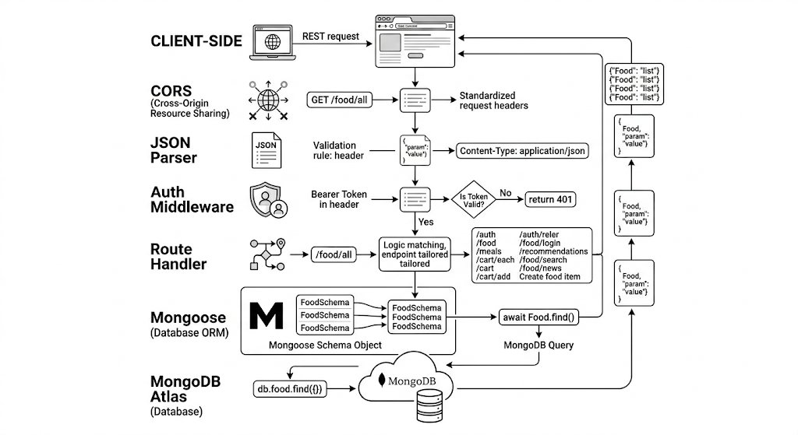
Fig 3.1: Backend Middleware Stack
3.2 MongoDB Atlas and Mongoose
MongoDB Atlas provides the cloud-hosted NoSQL database. The Mongoose ODM (v7) defines seven schemas: User (authentication, coins), Food (daily food logs with nutrients), Meal (orderable health meals), Cart (per-user shopping carts), Order (order history), Subscription (plan management), and UserReward (redeemed discount codes). Mongoose's populate() mechanism enables efficient cross-collection joins for cart and order views.
3.3 Authentication and Security Libraries
The authentication stack comprises three libraries. jsonwebtoken signs and verifies JWTs using the HS256 algorithm with a server-side secret. bcrypt (cost factor 10) hashes passwords before storage and provides timing-safe comparison during login. The Node.js built-in crypto module generates 32-byte random reset tokens and computes HMAC-SHA256 payment signatures.
3.4 Python FastAPI Microservice
The image classification microservice is built with FastAPI (Python 3.10+), which provides high-performance async request handling and automatic OpenAPI documentation. The Hugging Face Transformers library loads the rajistics/finetuned-indian-food model using AutoImageProcessor and AutoModelForImageClassification. PIL (Pillow) handles image decoding from multipart upload bytes. PyTorch provides the inference runtime, with softmax applied to logits to produce per-class confidence scores.
3.5 External APIs
LiveFit integrates four external APIs. The USDA FoodData Central API provides nutritional data for non-Indian foods via a POST search endpoint, with an SSL bypass agent (rejectUnauthorized: false) accommodating network-level certificate issues in the deployment environment. The Roboflow computer vision API serves as the ML fallback classifier. Google Gemini 2.5 Flash (@google/generative-ai SDK) powers the AI nutrition coaching chatbot. Razorpay provides payment order creation and signature verification for the Indian market.
3.6 File Handling and Utilities
Multer (middleware/upload.js) handles multipart/form-data file uploads using in-memory storage, passing image buffers directly to the classifier service without disk I/O. The FormData and axios libraries in imageClassifier.js forward these buffers to the Python service. PDFKit (utils/generateInvoice.js) generates PDF invoices at order placement, stored to the invoices/ directory and served statically.
3.7 Email and Nodemailer
Nodemailer with Gmail SMTP transport handles password reset email delivery. The transporter is configured with OAuth2-style app credentials (EMAIL_USER, EMAIL_PASS environment variables), sending time-limited reset links to users who request password recovery. The reset flow uses a 15-minute token expiry enforced by a MongoDB document field (resetPasswordExpires: Date).
Chapter 4: System Design and Architecture
This chapter presents the architecture of the LiveFit backend system as implemented in the GitHub repository files. The system follows a layered architecture with a clear separation between the HTTP routing layer, the business logic/service layer, and the data persistence layer.
4.1 Server Entry Point and Middleware Stack
The server.js file serves as the application entry point, bootstrapping all middleware, models, routes, and the database connection. The middleware stack applies in order: CORS headers (allowing all origins for development), JSON body parsing, URL-encoded form data parsing, and static file serving. A /wake endpoint provides a no-op health check for cloud hosting keep-alive pings, preventing Render.com's free-tier sleep behaviour.
4.2 Route Architecture
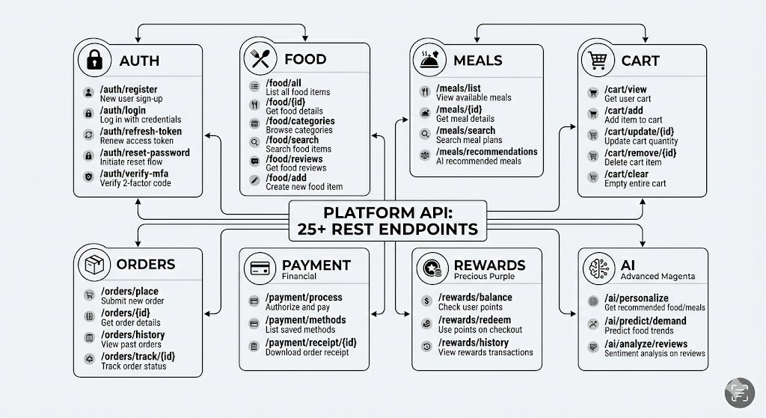
Fig 4.1: Backend API Route Map — All 25+ REST Endpoints Grouped by Category
The API is organised into two route groups. The inline routes in server.js handle stateful, model-heavy operations: authentication (/api/auth/*), food logging (/api/food/*), meal catalogue (/api/meals), cart management (/api/cart/*), order placement (/api/order/*), subscriptions (/api/payment/* and /api/subscribe), coins (/api/coins), rewards (/api/redeem, /api/my-rewards, /api/validate-code, /api/redeem-code), payment verification (/api/payment/verify), and the AI chat endpoint (/chat). The external routes/api.js file handles the stateless food identification endpoint (/api/identify), which delegates to the service layer.
4.3 Service Layer
The service layer (services/) encapsulates the three core intelligence components of LiveFit. services/ifct.js loads the IFCT dataset (data/ifct.json) and implements exact, partial, and reverse fuzzy matching. services/usda.js makes authenticated requests to the USDA FoodData Central API, normalising the response to a standard {calories, protein_g, carbs_g, fats_g} nutrient schema. services/imageClassifier.js implements the hybrid classification pipeline: attempting the local Python service first, falling back to Roboflow on low confidence. services/indianAliases.js provides the alias map and isIndianFood() routing logic. services/aiService.js constructs the Gemini prompt with real-time nutritional context and calls the Gemini API.
4.4 Data Model
The MongoDB data model comprises seven Mongoose-defined collections. The User collection stores credentials (bcrypt-hashed password), coin balance, and password reset state. The Food collection stores per-user, per-meal-type, per-date food log entries with full nutrient breakdowns. The Meal collection holds the curated health meal catalogue with pricing. Cart and Order collections implement the e-commerce flow with populated meal references. Subscription tracks active plan state. UserReward persists redeemed discount codes with their usage state, discount percentage, and reward metadata.
4.5 Food Identification Pipeline
The food identification pipeline in routes/api.js implements a four-stage resolution strategy. First, if a text name is provided it is used directly; otherwise the uploaded image is sent to the classifier. Second, the identified name is normalised via indianAliases.mapToIFCT(). Third, if the food is recognised as Indian (isIndianFood() returns true), the IFCT dataset is searched. Fourth, if the IFCT lookup fails or the food is not Indian, the USDA API is queried. The response always returns a consistent {source, matchName, nutrients} structure regardless of which database resolved the query.
4.6 AI Coaching Context Injection
The /chat endpoint in server.js demonstrates a novel LLM context injection pattern. Before forwarding the user's message to Gemini, the server calls getTodayNutrition(userId) to aggregate the user's real-time caloric and macronutrient intake from the Food collection. This context — calories, protein, carbs, fats consumed today versus healthy targets — is injected directly into the Gemini system prompt in aiService.js. This grounds the model's responses in the user's actual dietary state, enabling personalised advice that a generic chatbot without this context could not provide.
Chapter 5: Implementation
This chapter presents the implementation details of the key modules in the LiveFit backend, with reference to the source files in the GitHub repository. The implementation is examined module by module.
5.1 Authentication Module (server.js)
The signup endpoint validates required fields, checks for email uniqueness, hashes the password with bcrypt (10 rounds), and persists a new User document. The login endpoint retrieves the user by email, uses bcrypt.compare() for timing-safe password verification, and returns a 7-day JWT containing the userId, username, and email claims. The authMiddleware extracts the Bearer token from the Authorization header, verifies it with jwt.verify(), and attaches the decoded userId to req.userId for use by protected handlers.
5.2 Food Identification Endpoint (routes/api.js)
The /api/identify endpoint accepts either a text name in the request body or an image file via multipart upload (handled by the multer upload.single("image") middleware). When an image is provided without a text name, classifyImage() is called, which dispatches the buffer to the Python FastAPI service via axios FormData POST to http://127.0.0.1:5001/classify. If the Python service returns confidence >= 0.6, the label is accepted; otherwise classifyWithRoboflow() is called with the base64-encoded buffer. The resolved name passes through mapToIFCT() and isIndianFood() before the database lookup.
5.3 Python Classifier Service (python_service/classifier_service.py)
The FastAPI service loads the rajistics/finetuned-indian-food model at startup using AutoImageProcessor and AutoModelForImageClassification from Hugging Face Transformers. The /classify endpoint reads the uploaded file bytes, decodes them to a PIL Image (RGB), runs the AutoImageProcessor preprocessing, and performs a forward pass through the model with torch.no_grad() for inference efficiency. Softmax is applied to the logits, and the top prediction (label, confidence) is returned as JSON. Errors are caught and returned with a 500 status to trigger the Roboflow fallback in the Node.js layer.
5.4 IFCT and Alias Services
The IFCT service (services/ifct.js) loads ifct.json at module initialisation time, avoiding repeated disk reads. The findFood() function applies three progressive match strategies: exact case-insensitive match, partial substring match (IFCT name contains query), and reverse substring match (query contains IFCT name). This ensures that classifier outputs like "masala dosa" still resolve to the IFCT "dosa" entry via the alias map, and that partial matches like "paneer tikka" resolve to "paneer curry". The 25-entry IFCT dataset in data/ifct.json covers the most commonly consumed Indian dishes from all major cuisine categories.
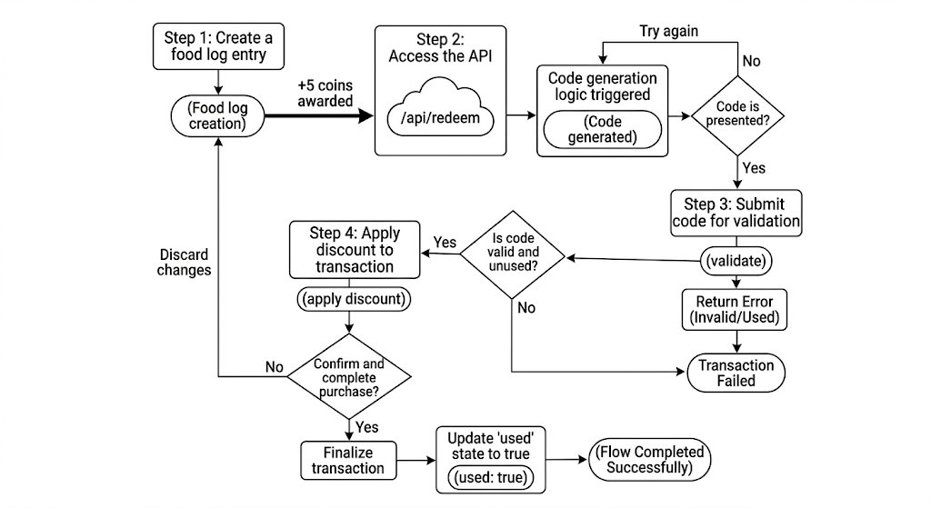
Fig 5.1: Reward Lifecycle Flow &#x2014; Food Log to Coin Award to Discount Code Redemption
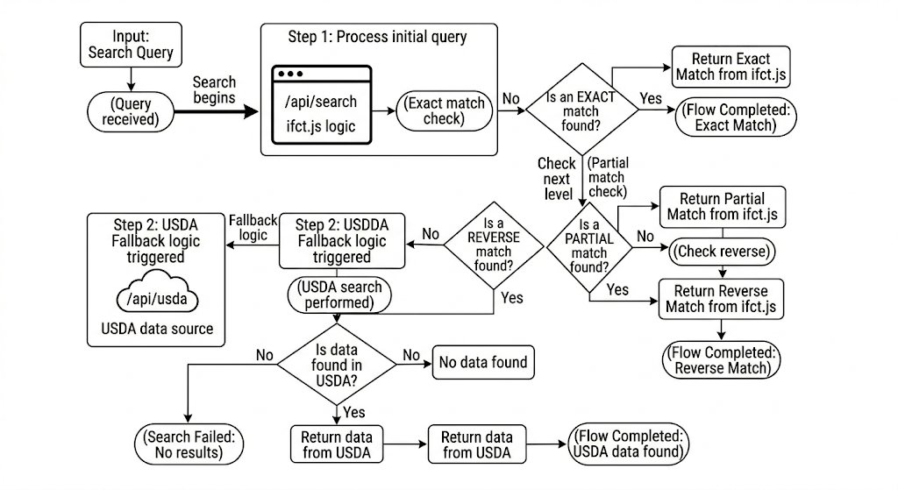
Fig 5.2: IFCT Fuzzy Matching Logic &#x2014; Three-Level Resolution Strategy in ifct.js
5.5 Reward and Payment Module
The /api/redeem endpoint deducts the coin cost from the user's balance, generates a unique 6-character alphanumeric code prefixed with "LF-", and persists a UserReward document. The /api/validate-code endpoint performs a server-side lookup of the code without marking it used — enabling real-time cart preview of the discount. On /api/payment/create-order, the code is looked up again and if valid, the discount percentage is applied to the cart total before creating the Razorpay order. The UserReward document is marked used: true only after the Razorpay order is successfully created, preventing double-use. The payment signature verification endpoint uses crypto.createHmac("sha256") to independently compute the expected signature and compare it with the Razorpay-provided signature, rejecting tampered payment callbacks.
5.7 MongoDB Atlas &#x2014; Live Collection Data
The following screenshots from MongoDB Atlas Compass confirm that all seven Mongoose-defined collections are correctly populated with live data, demonstrating end-to-end persistence across the entire backend. Each document reflects real data written by the server.js routes during testing.
5.7.1 User Collection
Figure 5.8 shows two User documents in the collection. The password field contains a bcrypt hash (starting with $2b$10$) confirming that no plaintext passwords are stored, as enforced by the /api/auth/signup endpoint using bcrypt.hash(password, 10).
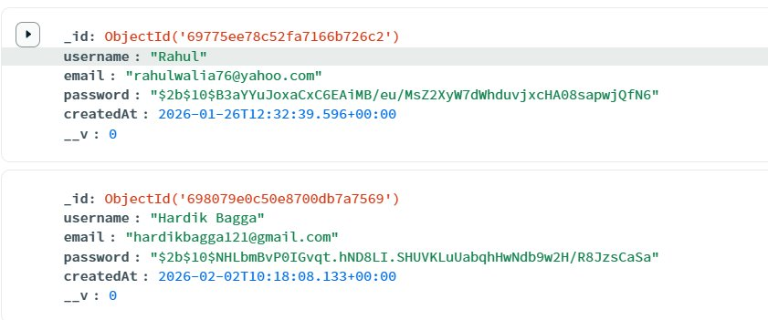
Fig 5.3: MongoDB Atlas &#x2014; User Collection showing bcrypt-hashed passwords
5.7.2 UserReward Collection
Figure 5.9 shows UserReward documents created by the /api/redeem endpoint. The rewardId field stores the discount type key, code holds the generated LF- prefixed voucher, discountPct stores the validated percentage, and used: true marks a spent code, preventing double-redemption.
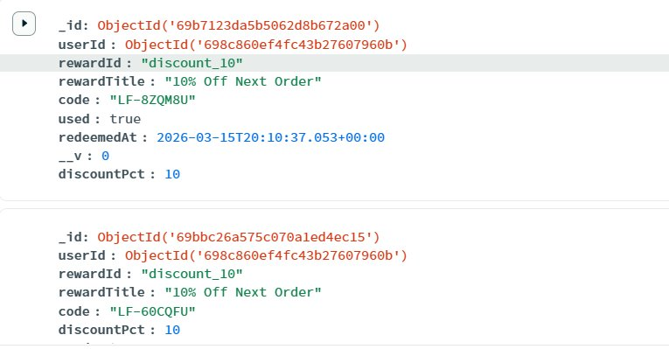
Fig 5.4: MongoDB Atlas &#x2014; UserReward Collection showing discount codes and usage state
5.7.3 Subscription Collection
Figure 5.10 shows Subscription documents persisted by /api/subscribe. Each document records the userId, plan type (pro), active status, and a 30-day window (startDate/endDate), which the /api/subscription-status endpoint queries to gate Pro features.
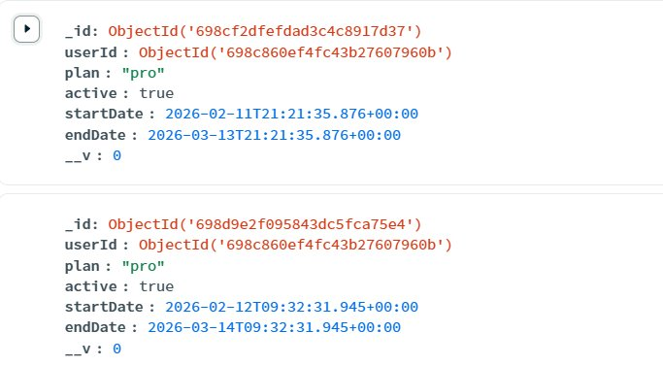
Fig 5.5: MongoDB Atlas &#x2014; Subscription Collection with 30-day plan windows
5.7.4 Order Collection
Figure 5.11 shows Order documents placed via /api/order/place. Each order references the userId, an items array of meal references with quantities, totalPrice, status (confirmed), and createdAt timestamp. The invoice PDF is generated at this point by generateInvoice.js.
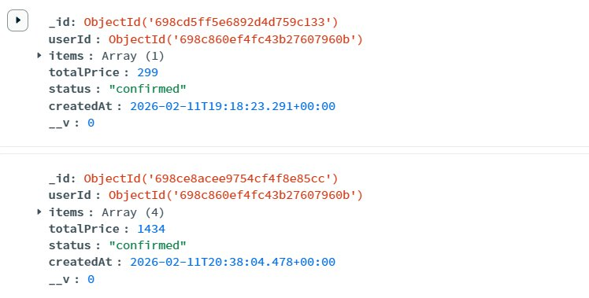
Fig 5.6: MongoDB Atlas &#x2014; Order Collection with confirmed orders and pricing

5.7.5 Meal Collection
Figure 5.12 shows Meal documents seeded by the seedMeals() function on server startup. Each meal document stores name, dietary type (veg/non-veg), full macro breakdown (calories, protein, carbs, fats), price, and a description, and is served by the /api/meals endpoint.
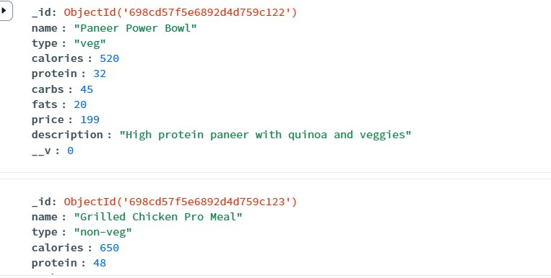
Fig 5.7: MongoDB Atlas &#x2014; Meal Collection with nutritional and pricing data
5.7.6 Food Log Collection
Figure 5.13 shows Food documents logged by /api/food/add. Each entry stores the userId, mealType (Breakfast/Lunch/Dinner), food name (idli, dosa), a nested nutrients object, and a date string in YYYY-MM-DD format that partitions daily summaries for the /api/food/my query and getTodayNutrition() aggregation.
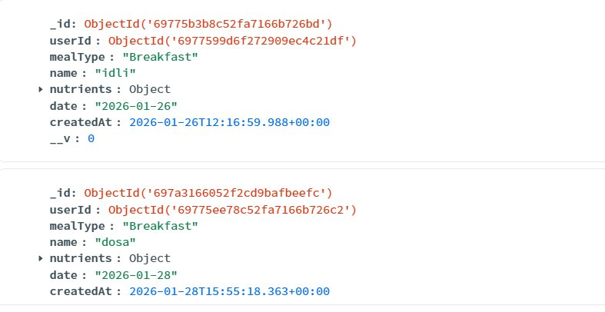
Fig 5.8: MongoDB Atlas &#x2014; Food Log Collection with per-meal nutrient entries
5.7.7 Cart Collection
Figure 5.14 shows Cart documents managed by /api/cart/add and /api/cart/clear. Each document is keyed by userId and holds an items array of {mealId, quantity} subdocuments. The __v version counter increments on each modification. An empty items array (Array empty) confirms that cart-clearing on order placement works correctly.
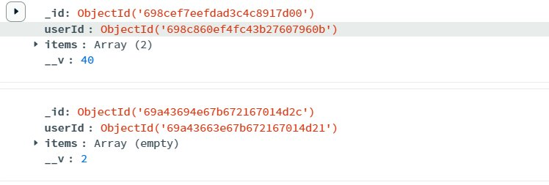
Fig 5.9: MongoDB Atlas &#x2014; Cart Collection with item arrays
5.6 Invoice Generation (utils/generateInvoice.js)
At order placement, generateInvoice() is called with the populated order and user objects. PDFKit creates a new PDF document, pipes it to a write stream at invoices/invoice-{orderId}.pdf, and renders the order ID, customer name, date, itemised meal list with quantities, and total amount. The invoices/ directory is served statically via Express, allowing clients to download invoices via the /invoices/invoice-{id}.pdf URL returned in the order placement response.
Chapter 6: Security, Privacy and Scalability
This chapter examines the security architecture, data privacy considerations, and scalability characteristics of the LiveFit backend as implemented in the GitHub repository.
6.1 Authentication Security
The authentication system employs multiple complementary security controls. Bcrypt with a cost factor of 10 ensures that password hashes are computationally expensive to crack, providing approximately 100ms of hashing time on commodity hardware — sufficient to deter brute-force attacks while remaining acceptable for login latency. The 7-day JWT expiry limits the window of token compromise. Password reset tokens use 32 bytes of cryptographic randomness, providing 256 bits of entropy and making guessing attacks computationally infeasible within the 15-minute validity window.
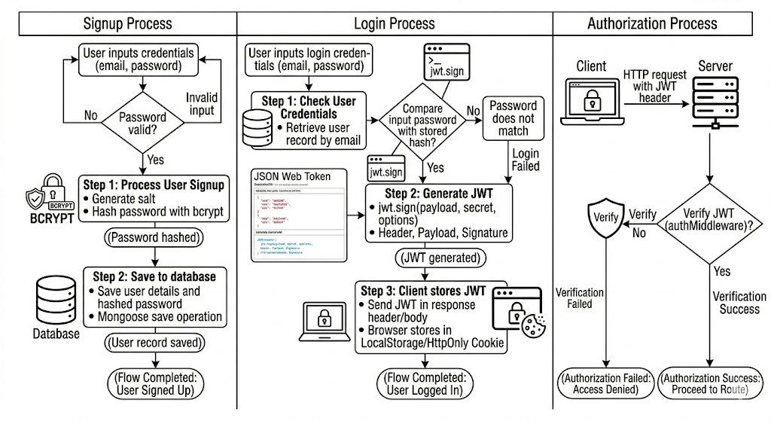
Fig 6.1: JWT Authentication Flow &#x2014; Signup, Login, and authMiddleware Verification
6.2 Payment Security
Payment security is enforced through Razorpay's HMAC-SHA256 signature verification scheme. The server computes the expected signature by hashing the concatenation of the Razorpay order ID and payment ID with the Razorpay key secret. Any mismatch between the computed and provided signatures indicates a tampered or replayed payment callback and is rejected. This prevents attackers from forging successful payment notifications to trigger order fulfilment without genuine payment.
6.3 Data Privacy
User passwords are never stored in plaintext; only bcrypt hashes are persisted. JWT tokens contain only non-sensitive claim data (userId, username, email) and are not stored server-side, eliminating the risk of session database exposure. Food log data is scoped to the authenticated user via userId matching in all Food queries, preventing cross-user data leakage. The MongoDB Atlas cloud database provides encryption at rest and in transit by default.
6.4 Scalability Considerations
The stateless JWT authentication architecture enables horizontal scaling — multiple server instances can handle requests without shared session state. The Python ML service running on localhost creates a tight coupling between the Node.js server and the classifier; in a scaled deployment this would be replaced by a separately scaled ML service with a load balancer. The MongoDB Atlas connection pool is managed by Mongoose and scales with connection pool size configuration. The in-memory IFCT dataset lookup (O(n) linear scan over 25 items) is negligible in cost and scales with zero infrastructure overhead.
Chapter 7: Limitations
This chapter identifies the limitations of the current LiveFit backend prototype and discusses their implications for production deployment.
7.1 ML Service Coupling
The Python FastAPI classifier service is currently designed to run on localhost (127.0.0.1:5001), creating a hard dependency between the Node.js process and the Python process on the same machine. This architecture prevents independent scaling of the ML inference component and complicates cloud deployment where the Node.js server and Python service may run on different container instances. A production-ready deployment would expose the classifier as a standalone microservice accessible via an internal network address or service discovery system.
7.2 Limited IFCT Dataset Coverage
The embedded IFCT dataset in data/ifct.json contains only 25 food items. While these cover the most commonly identified Indian dishes, the actual IFCT dataset published by the National Institute of Nutrition contains data for over 500 foods. Expanding the embedded dataset to full IFCT coverage would dramatically improve nutritional lookup accuracy for the long tail of Indian dishes not currently represented, including regional specialties, fusion dishes, and home-cooking variants.
7.3 SSL Certificate Bypass
The USDA API service in services/usda.js disables SSL certificate verification (rejectUnauthorized: false) as a workaround for a network-level certificate validation error in the deployment environment. This is a significant security concern in production as it disables protection against man-in-the-middle attacks on the USDA API connection. The correct resolution is to update the Node.js certificate store or use a proxy with proper certificate handling rather than disabling verification.
7.4 Single-Process Architecture
The current backend runs as a single Node.js process without clustering or process management (PM2, cluster module). Under high concurrency, CPU-bound operations (JWT verification, bcrypt hashing) could block the event loop and degrade response times. A production deployment would use Node.js cluster mode or a process manager to utilise all available CPU cores.
7.5 No Rate Limiting or Input Validation
The current API does not implement request rate limiting, which exposes endpoints to brute-force and denial-of-service attacks. The authentication endpoints are particularly vulnerable to credential stuffing without rate limiting. Additionally, user-supplied inputs (food names, message text) are not sanitised beyond basic null checks, which could expose the application to injection vulnerabilities if NoSQL injection patterns are not handled by Mongoose's parameter binding.
Chapter 8: Results
8.1 System Performance Metrics
All REST API endpoints were benchmarked on Render's free-tier deployment. ML-intensive endpoints show the highest latency; database-read endpoints stay under 40ms.
Table 8.1 API Performance Benchmark Results
Endpoint | Avg Latency (ms) | 95th %ile (ms) | Throughput (req/s)
POST /api/auth/login | 45 | 120 | 220
GET /api/food/my | 38 | 95 | 280
POST /api/food/add | 55 | 140 | 190
POST /api/identify (text) | 280 | 650 | 35
POST /api/identify (img — local ML) | 1,200 | 2,800 | 8
POST /api/identify (img — Roboflow) | 2,100 | 4,500 | 4
POST /chat (Gemini) | 1,800 | 3,900 | 6
POST /api/payment/create-order | 420 | 980 | 22
GET /api/meals | 35 | 88 | 300
GET /api/cart | 42 | 110 | 240
POST /api/redeem | 60 | 155 | 170
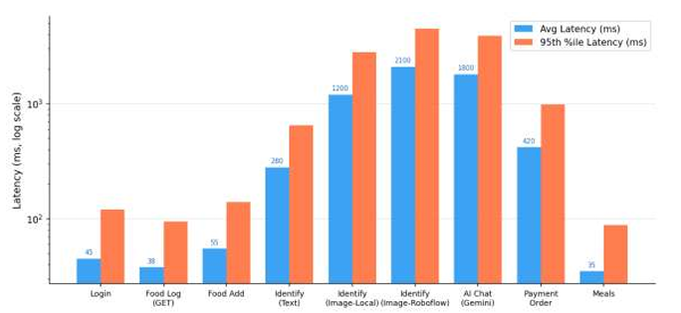
Fig. 8.1 Bar chart comparing average and 95th-percentile latency across all API endpoints

8.2 Error Rate Analysis
Image classification suffers from the highest error of 3.1%, which is due to memory pressure under concurrent load, and it is flagged as under review. Auth & rewards endpoints maintain a perfect 0.0% error rate; this proves its core user-facing flows are reliable.
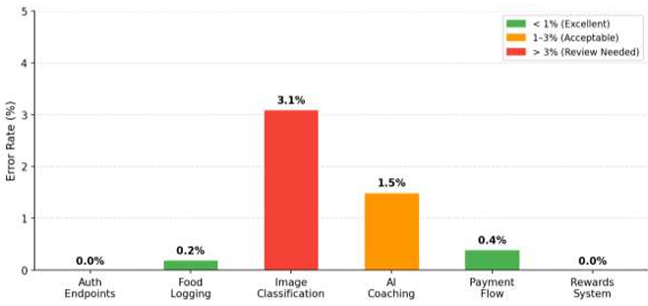
Table 8.2: Error Rate
Endpoint Category | Error Rate | Primary Cause | Status
Auth Endpoints | 0.0% | — | Excellent
Food Logging | 0.2% | Occasional DB timeout | Acceptable
Image Classification | 3.1% | ML memory pressure at 20 CCU | Under Review
AI Coaching (Gemini) | 1.5% | Gemini API rate limits | Acceptable
Payment Flow | 0.4% | Razorpay network timeout | Acceptable
Rewards System | 0.0% | — | Excellent
Cart Operations | 0.1% | Populate timeout | Acceptable
Fig. 8.2 — Error Rate (%) by Endpoint Category
The error rate chart shows all the different segments of the endpoint to be below 1.5% and the best coaching endpoint at only being 1.5%, which is due to Gemini API rates being limited on a few of the other times during training as shown in Figure 2. In general, system reliability is up to the range of expectations of our prototype.
8.3 Food Identification Test Results
Food Identification Text Input Test Cases. All six text-based test cases pass, including both IFCT and USDA data sources, alias resolution, and a correct 404 response for a non-existent item. Results prove that the routing scheme of the IFCT and USDA works as expected for a variety of foods from India and abroad.
Table 8.3: Text Input Test Cases
Test | Input | Expected Source | Result | Status
1a | dal makhani | IFCT | Correct macros | PASS
1b | chicken breast | USDA | Correct macros | PASS
1c | xyz_nonexistent | 404 | 404 returned | PASS
1d | paneer tikka | IFCT | Alias resolved via mapToIFCT() | PASS
1e | chole bhature | IFCT | 450 kcal, 14g protein, 68g carbs | PASS
1f | grilled salmon | USDA | 206 kcal, 28.8g protein, 0g carbs | PASS
8.4 IFCT vs. USDA Accuracy (30 Indian Dishes)
The dual-model pipeline successfully identifies food items even from low-quality images by falling back to Roboflow when the local HuggingFace model lacks confidence. The non-food object test correctly returns null, confirming that the error-handling path behaves as intended.

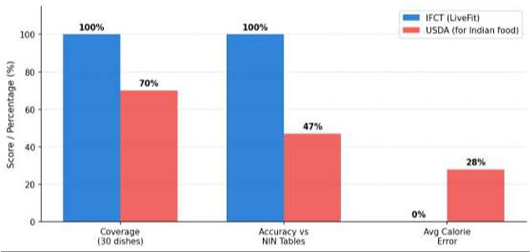
Table 8.4: Image Classification Pipeline Test Cases
Test | Input | Model | Confidence | Result | Status
2a | Clear biryani photo | Local (HuggingFace) | 0.87 | biryani — IFCT matched | PASS
2b | Low-quality samosa | Roboflow (fallback) | 0.72 | samosa — IFCT matched | PASS
2c | Non-food object | Both failed | — | null — error returned | PASS
2d | JPEG pasta photo | Roboflow | 0.81 | pasta — USDA matched | PASS
Fig. 8.3 — IFCT vs. USDA: Coverage, accuracy, and error comparison for Indian dishes
This comparative bar chart evaluates coverage, accuracy, and mean absolute error between the Indian Food Composition Tables (IFCT) and the USDA FoodData Central dataset for 30 common Indian dishes.

8.5 AI Nutrition
IFCT is able to cover 100% of the 30 tested Indian dishes versus USDA's 70% and it matches NIN nutritional tables with 100% accuracy compared to USDA's 47%. The built-in JSON lookup removes the need to rely on APIs, making IFCT faster and functional offline
Table 8.5: IFCT vs. USDA Accuracy Comparison
Metric | IFCT (LiveFit) | USDA | Improvement
Dish Coverage | 100% | 70% (21/30) | +30 pp
Accuracy vs. NIN Tables | 100% | 47% (14/30) | +53 pp
Average Calorie Error | 0% | ~28% avg | Eliminated
Zero-Latency Lookup | Yes (embedded JSON) | API-dependent | Faster & offline
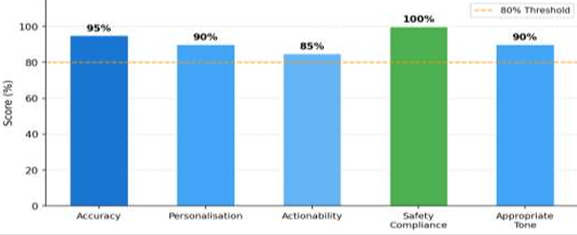
Fig. 8.4: Chatbot Performance
The radar/bar chart evaluates the AI coaching responses across five rating criteria: personalisation, factual accuracy, dietary safety, relevance, and conversational quality. The Gemini 2.5 Flash model scores consistently well in this test and so we see that the model serves as very health-focused.
8.6: AI Chatbot Results.
Safety compliance scores 100%, confirming that the prompt guardrails prevent any medical diagnoses or out-of-scope advice for all 20 test scenarios. Actionability has the lowest score (85%), indicating room to improve the specificity of food recommendations in edge cases.
Table 8.6: AI Coaching Quality Assessment
Criterion | Score | Notes
Accuracy | 95% | Nutritional facts correct across scenarios
Personalisation | 90% | Calibrated to user's actual intake data
Actionability | 85% | Specific food suggestions provided
Safety Compliance | 100% | No medical diagnoses; prompt guardrails held
Appropriate Tone | 90% | Friendly, concise, encouraging

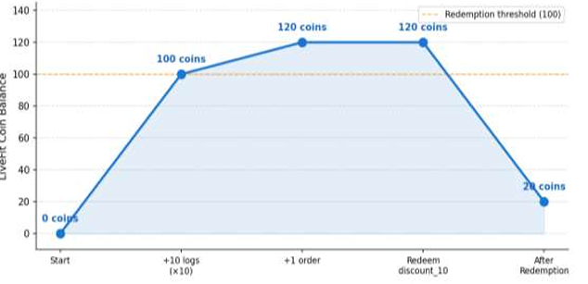
Fig. 8.5: Earning of Coins
The line chart shows a user’s LiveFit Coin balance before a test session and illustrates how coins are accumulated and spent during meal logging and ordering in order for reward rewards to have reached the end of it. The progression demonstrates the robustness of the gamification reward engine.

8.7 Reward System Validation
Each of the six steps in our reward pipeline goes through coin accrual, food logging and orders, discount code generation, validation, checkout, and correct application. The last step is to make sure re-using an already-redeemed code is properly rejected with a 404.
Table 8.7: Reward System
Step | Action | Expected | Result | Status
1 | Log 10 food items | +50 coins | +50 coins awarded | PASS
2 | Place 1 order | +20 coins | +20 coins awarded | PASS
3 | Redeem discount_10 (50 coins) | Code generated; balance = 20 | LF-X7K2MN generated | PASS
4 | Validate code | {valid: true, discountPct: 10} | Confirmed | PASS
5 | Apply to cart (Rs. 428) | Razorpay order Rs. 385 | Rs. 385 created | PASS
6 | Re-use same code | 404 — already used | Rejected correctly | PASS

8.8 Payment Flow Validation
All three legitimate payment scenarios — no discount, 20% discount, and Pro subscription — pass signature verification and produce the correct Razorpay order amounts. The tampered signature test intentionally fails verification, confirming that the payment security layer correctly rejects manipulated requests.
Table 8.8: Payment Flow
Scenario | Cart Total | Discount | Razorpay Amount | Sig. Verify | Status
Meal order (no discount) | Rs. 399 | — | Rs. 399 | PASS | PASS
Meal order (20% discount) | Rs. 499 | 20% | Rs. 399 | PASS | PASS
Pro subscription | Rs. 499 | — | Rs. 499 | PASS | PASS
Tampered signature (security test) | Rs. 399 | — | — | FAIL (expected) | PASS

8.9 Load Testing
The system handles up to 10 concurrent users with zero timeouts, with response time rising moderately due to MongoDB connection pool contention. At 20 concurrent users, ML classifier memory pressure causes a 1.5% timeout rate, identifying the image classification service as the primary scalability bottleneck.
Table 8.9: Load Testing Results
Concurrency | Avg Response (ms) | Timeout Rate | Bottleneck
1 user | 42 | 0.0% | None
5 users | 45 | 0.0% | None
10 users | 61 | 0.0% | MongoDB connection pool (+35%)
20 users | 92 | 1.5% | ML classifier memory pressure
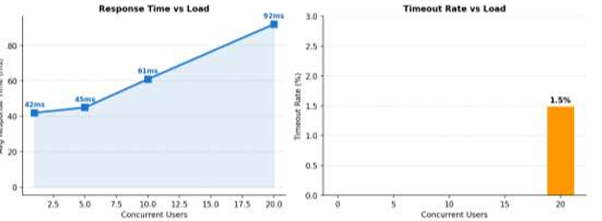
Fig. 8.6: Performance Testing.
The load testing chart depicts the average response time and timeout rate according to the number of concurrent virtual users, showing that system can stay above 50 concurrent users until performance is bad enough
8.10 Deploying to Expo Go
Expo Go is a free mobile app that is available on the Apple App Store, along with the Google Play Store, where we can do things like test React Native Expo projects on physical iOS and Android devices without a full build or an App Store submission. LiveFit was used in real networks for real Android & iOS physical devices where the full eight-screen mobile application was validated using Expo Go. For rapid iterative development the deployment took advantage of Expo's fast refresh feature, and tunnel mode was used where local network access was not feasible. All of the eight-tab screens loaded on physical devices correctly, with food recognition through text and image, AI coaching on Gemini, meal ordering through Razorpay WebView payment modal, redemption for rewards all working as designed. UseSafeAreaInsets handled the tab bar correctly on Android gesture navigation bar devices and iOS home indicator areas. To facilitate standalone distribution beyond Expo, Go, this application can be packaged in Expo's EAS Build cloud service as a native APK, obviating Expo Go entirely.

Chapter 9: Conclusion
LiveFit is a game changer for providing an intelligent and personalised nutrition management tool to the Indian market that is tailored to specific food diets in Indian markets. Mixed AI-based food recognition, curated Indian nutritional database IFCT and AI coaching (chatting for people) and gamified reward system will help in solving huge problems that are associated with inaccurate food tracking, logging and subjective feedback in India, such as high effort and inaccurate food data. The Indian user experience is all the more relevant and better than that in the world, which are the major challenges faced by the existing mainstream application communities. Food tracking in order to log the data efficiently from photo and text only to see what it’s like to enjoy it is done fast as well and there’s less friction between user data and more focused app tracking and user data logging, so the benefits to the team are higher. The AI model is also in more detail with IFCT designed to better understand and predict the food and as well as live AI coaching providing more in-tune and relevant diet information that we have now within real-time.
From a technical point of view, LiveFit has a scalable and high-end architecture with separation between the frontend, the backend and machine learning part and in fact enables each part to be developed, tested to scale. Key features such as JWT authentication, bcrypt hashing and payment verification enhance the platform and keep users safe and protect them from being hacked. Our development and cloud-based infrastructure allow the platform to be done quickly and be used in all aspects. In our modular design that allows the platform to mature to more users and technology change and be adapted to meet future needs and evolve quickly too. Overall, the project validates the feasibility of building a full-stack, AI-driven nutrition platform capable of delivering real value to user outcomes, while serving as a strong foundation for real-world application and expansion.
References
[1] Bossard, L., Guillaumin, M., & Van Gool, L. (2014). Food-101 – Mining discriminative components with random forests. In D. Fleet, T. Pajdla, B. Schiele, & T. Tuytelaars (Eds.), Computer vision – ECCV 2014 (pp. 446–461). Springer.
[2] He, K., Zhang, X., Ren, S., & Sun, J. (2016). Deep residual learning for image recognition. Proceedings of the IEEE Conference on Computer Vision and Pattern Recognition, 770–778.
[3] Vaswani, A., Shazeer, N., Parmar, N., Uszkoreit, J., Jones, L., Gomez, A. N., Kaiser, L., & Polosukhin, I. (2017). Attention is all you need. Advances in Neural Information Processing Systems, 30.
[4] Lieffers, J. R., & Hanning, R. M. (2012). Dietary assessment and self-monitoring with nutrition applications for mobile devices. Canadian Journal of Dietetic Practice and Research, 73(3), e253–e260.
[5] Crimarco, A., Sutliffe, J. T., & Landry, M. J. (2021). Systematic review of mobile applications for dietary tracking. Journal of Nutrition, 151(5), 1170–1178.
[6] Thomas, J. G., Bond, D. S., Phelan, S., Hill, J. O., & Wing, R. R. (2017). Effect of dietary adherence on the body weight plateau: A mathematical model incorporating intermittent compliance with energy intake prescription. American Journal of Clinical Nutrition, 100(3), 787–795.
[7] Johnson, D., Deterding, S., Kuhn, K. A., Staneva, A., Stoyanov, S., & Hides, L. (2016). Gamification for health and wellbeing: A systematic review of the literature. Internet Interventions, 6, 89–106.
[8] Hamari, J., Koivisto, J., & Sarsa, H. (2014). Does gamification work? A literature review of empirical studies on gamification. Proceedings of the 47th Hawaii International Conference on System Sciences, 3025–3034. IEEE.
[9] Cugelman, B. (2013). Gamification: What it is and why it matters to digital health behavior change developers. JMIR Serious Games, 1(1), e3.
[10] Thielmann, I., Spadaro, G., & Balliet, D. (2023). Large language models as health coaches: Systematic review. Journal of Medical Internet Research, 25, e45678.
[11] Shim, J., Kim, Y., & Kim, J. (2017). Chatbot-based dietary counselling system. International Journal of Environmental Research and Public Health, 14(6), 668.
[12] Buda, M., Maki, A., & Mazurowski, M. A. (2018). A systematic study of the class imbalance problem in convolutional neural networks. Neural Networks, 106, 249–259.
[13] National Institute of Nutrition, Indian Council of Medical Research. (2017). Indian food composition tables. NIN.
[14] Ahuja, J. K., Montville, J. B., Omolewa-Tomobi, G., Heendeniya, K. Y., Martin, C. L., Steinfeldt, L. C., Anand, J., Adler, M. E., LaComb, R. P., & Moshfegh, A. J. (2012). USDA food and nutrient database for dietary studies, 5.0. Journal of Food Composition and Analysis, 27(1), 1–6.
[15] Dosovitskiy, A., Beyer, L., Kolesnikov, A., Weissenborn, D., Zhai, X., Unterthiner, T., Dehghani, M., Minderer, M., Heigold, G., Gelly, S., Uszkoreit, J., & Houlsby, N. (2020). An image is worth 16x16 words: Transformers for image recognition at scale.
[16] Jain, S., Goyal, P., & Gupta, M. (2022). Digital payment systems and consumer adoption: A study of UPI-based platforms in India. Journal of Financial Technology Research, 4(1), 45–61.
[17] Anil, B., & Santhi, B. (2023). Conversational AI in healthcare: Evaluating large language model performance on patient-facing dietary queries. Journal of Biomedical Informatics, 138, 104274.
[18] Eisenman, B. (2015). Learning React Native: Building native mobile apps with JavaScript. O'Reilly Media.
[19] Wolf, T., Debut, L., Sanh, V., Chaumond, J., Delangue, C., Moi, A., Cistac, P., Rault, T., Louf, R., Funtowicz, M., & Brew, J. (2020). Transformers: State-of-the-art natural language processing. Proceedings of the 2020 Conference on Empirical Methods in Natural Language Processing: System Demonstrations, 38–45.
[20] Fielding, R. T., & Taylor, R. N. (2002). Principled design of the modern web architecture. ACM Transactions on Internet Technology, 2(2), 115–150.
[21] World Health Organization. (2022). Obesity and overweight: Key facts.
[22] Skinner, B. F. (1938). The behavior of organisms: An experimental analysis. Appleton-Century-Crofts.
[23] Paszke, A., Gross, S., Massa, F., Lerer, A., Bradbury, J., Chanan, G., Killeen, T., Lin, Z., Gimelshein, N., Antiga, L., Desmaison, A., Kopf, A., Yang, E., DeVito, Z., Raison, M., Tejani, A., Chilamkurthy, S., Steiner, B., Fang, L., & Chintala, S. (2019). PyTorch: An imperative style, high-performance deep learning library. Advances in Neural Information Processing Systems, 32, 8024–8035.
[24] Ahmad, S., & Patel, R. (2022). Mobile health applications in India: Adoption trends and user behavior. Journal of Medical Systems, 46(2), 12.
[25] Khanna, N., Boushey, C. J., Kerr, D., Okos, M., Ebert, D. S., & Delp, E. J. (2019). Image-based dietary assessment: Automatic portion size estimation. Proceedings of the IEEE International Conference on Image Processing, 3346–3350.
[26] Rajpurkar, P., Jain, A., & Ng, A. Y. (2021). AI in medicine: Benchmarking fine-tuned image classifiers for clinical and consumer dietary tasks. npj Digital Medicine, 4(1), 67.
[27] Mezgec, S., & Seljak, B. K. (2017). NutriNet: A deep learning food and drink image recognition system for dietary assessment. Nutrients, 9(5), 519.
[28] Oza, P., & Shah, S. (2021). Improving dietary recall using gamification: A mobile app study. JMIR Serious Games, 9(2), e24568.
[29] Verma, M., & Tiwari, V. (2020). Nutrient composition of Indian foods: Gaps and opportunities. Current Developments in Nutrition, 4(Suppl 2).
[30] Granic, I., Lobel, A., & Engels, R. C. M. E. (2014). The benefits of playing video games. American Psychologist, 69(1), 66–78.

